*PROJECT REPORT*

-PROJECT TITLE-

Encryption and Decryption of data using Cryptography Algorithms

**SUBMITTED BY:**

# Diwyanshu

**2K19/CO/130**

AES Encryption : What is AES ?

AES stands for Advanced Encryption Standard. AES Encryption is a method for scrambling data (converting message into encrypted message, means converting into gibberish so no one can understand it). A key is used to mix up data such that it can be securely stored or transferred over a network, and only persons with the key can unscramble the data.

**Encryption:**

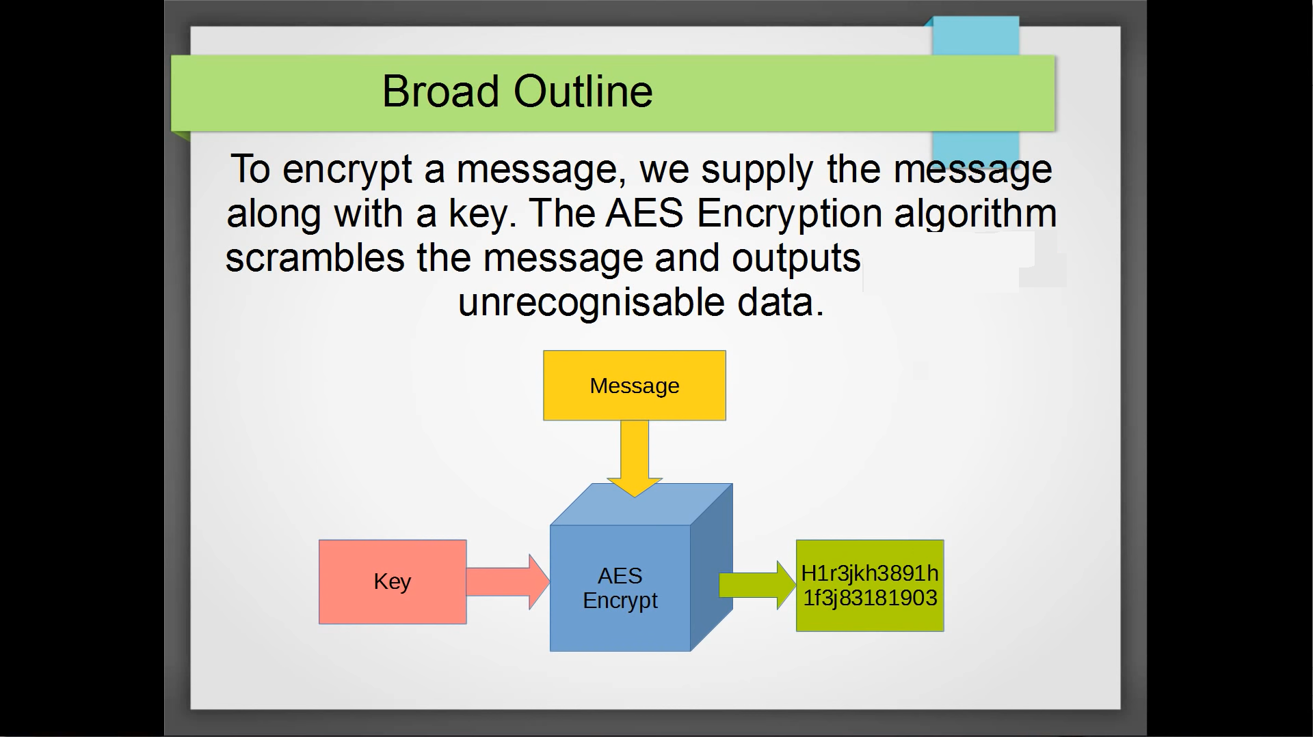

**Decryption:**

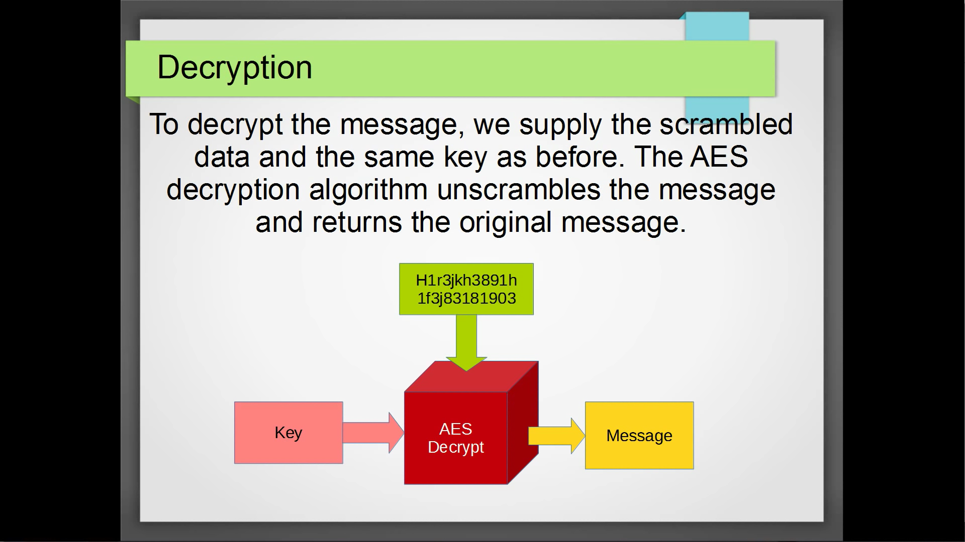

Quick Overview of Algorithm

**Broad outline:**

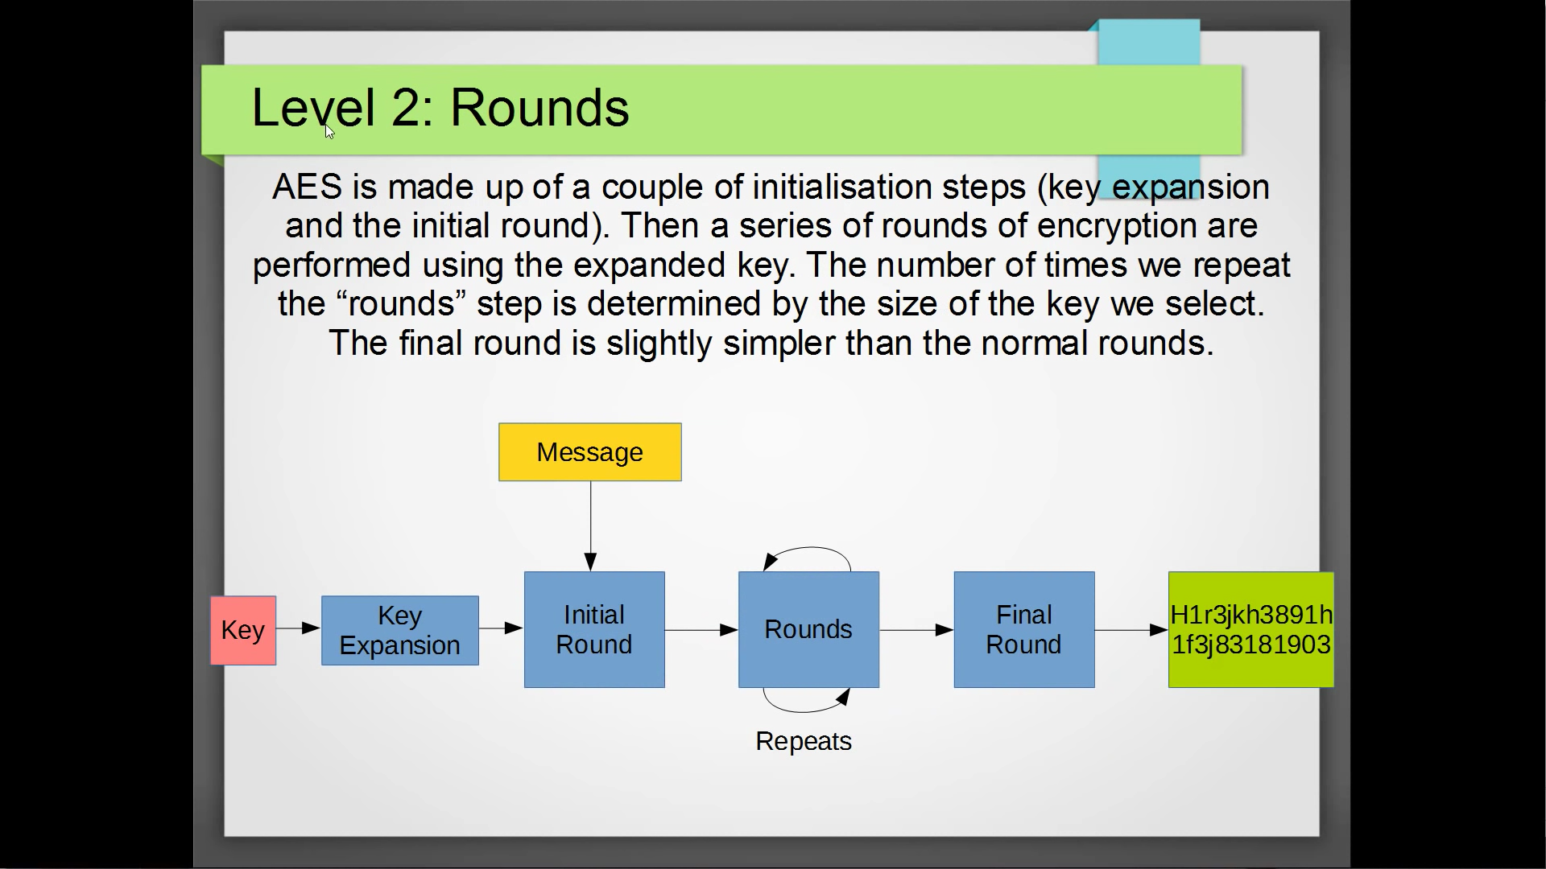

AES is made up of two of initialisation steps (Key expansion and the Initial round). Then a series of repetitive rounds of encryption are performed using the expanded key (expanded key obtained from key expansion round). The number of times we repeat the "rounds" step is determined by the size of the key we select. The final round is slightly simpler than the normal rounds. Finally our message is converted into encrypted message.

Number of rounds depend on size of key. 3 sizes of key are used in AES. More rounds means more secure.

* 10 rounds for 128 bit key (most common and fastest)
* 12 rounds for 192 bit key
* 14 rounds for 256 bit key (slowest but most secure)

**Summarising broad outline for a 128 bit (16 bytes) key**

1. Getting message and 16 byte key from user

16 byte key so total 11 rounds (One initialisation round and then 9 repeating rounds and then 1 final round. So total 1+9+1=11 rounds)

1. Perform Key Expansion.

16 byte key is expanded into 176 byte key (16*11=176)

Why Key Expansion? Because each round takes a 16 byte key but key for each round is a modified version of original key

1. Perform Initial Round.
2. Perform Repeating rounds.
3. Perform Final Round and give the encrypted message as output

Stages within Rounds

There are some stages performed within these rounds, namely

1. Add Round Key:
2. Substitute bytes or SubBytes
3. Shift Rows
4. Mix Columns

(Detailed description these stages is given afterwards)

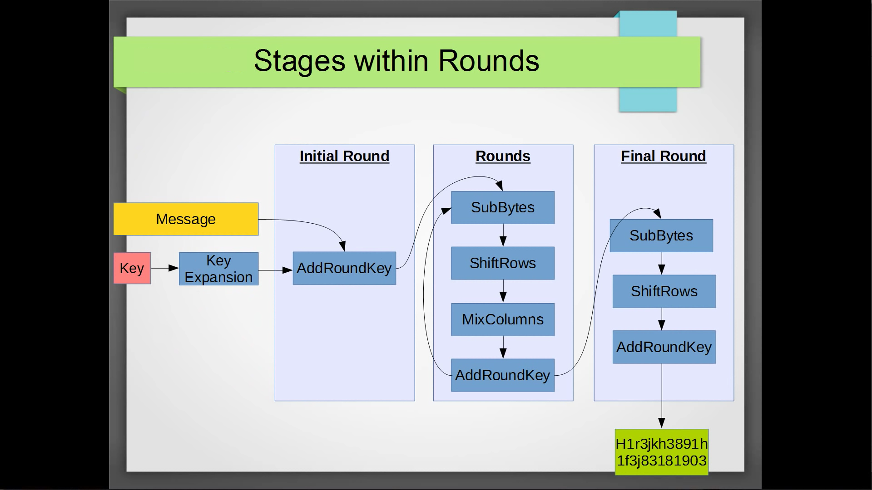

**Summarising all the information till now in C++ code**

The basic layout for the code (Description of the stages within rounds is done afterwards the basic layout)

#include<iostream>

using namespace std;

**// Functions**

void Key_Expansion(){}

void Add_Round_Key(){}

void Sub_Bytes(){}

void Shift_Rows(){}

void Mix_Columns(){}

void AES_Encrypt()

{

    Key_Expansion();

    Add_Round_Key();  //* Initial round

    //* Repetitive Rounds

    int n=9; // n = number of rounds

    for(int i=0;i<n;i++)

    {

        Sub_Bytes();

        Shift_Rows();

        Mix_Columns();

        Add_Round_Key();

    }

    //* Final Round

    Sub_Bytes();

    Shift_Rows();

    Add_Round_Key();

}

int main()

{

    char message[]="This is a message we will encrypt with AES!";

    char key[16]=

    {

        1, 2, 3, 4,

        5, 6, 7, 8,

        9, 10, 11, 12,

        13, 14, 15, 16

    };

    AES_Encrypt();

    return 0;

}

Description of Algorithm

In this section, we will walkthrough step by step how our algorithm works. We will define every function that we had written in our basic layout of the code. The algorithm for Advanced Encryption Standard (AES) consists of smaller, sub-algorithms namely SubBytes, ShiftRows, MixColumns, and AddRoundKey.

1. **AES_Encrypt**

void AES_Encrypt(unsigned char * message, unsigned char * key)

{

    //! we will copy the string to be encrypted in a new char[]

    //! we will take it in blocks of 128 bits/16 bytes of data

    unsigned char state[16];

    for(int i=0;i<16;i++)

    {

        state[i]=message[i];

    }

    Key_Expansion();

    Add_Round_Key(state,key); // whitening, initial round

    //! Rounds

    int n=1; // n = number of rounds

    for(int i=0;i<n;i++)

    {

        Sub_Bytes(state);

        Shift_Rows(state);

        Mix_Columns(state);

        Add_Round_Key(state, key);

    }

    //! Final Round

    Sub_Bytes(state);

    Shift_Rows(state);

    Add_Round_Key(state,key);

}

**Description:** We copy the input message into a new char array called state. We do it in blocks of 16 bytes.

The state and key are best visualised as a 4x4 grid.

Eg. If our message is “three five seven” and char key[16] is {84,79,78,32,119,110,106,84,111,101,110,119,32,32,101,111}

Message as 4x4 grid

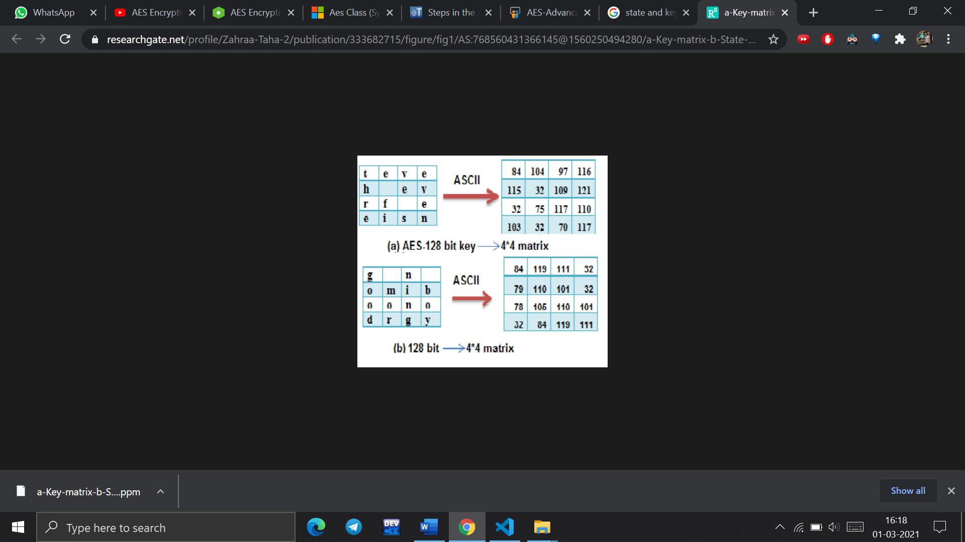

Key as 4x4 grid



1. **Add Round Key**

void Add_Round_Key(unsigned char *state, unsigned char * roundkey)

    {

        for(int i=0;i<16;i++)

            state[i] ^= roundkey[i];

    }

**Description:**

Every bit in the input is added to the corresponding bit in the round key and the result MOD 2 is stored in state (this is basically a XOR operation).

state [ i ] + roundkey [ i ] = result;

state [ i ] = result % 2 //( Modular division of result with 2)

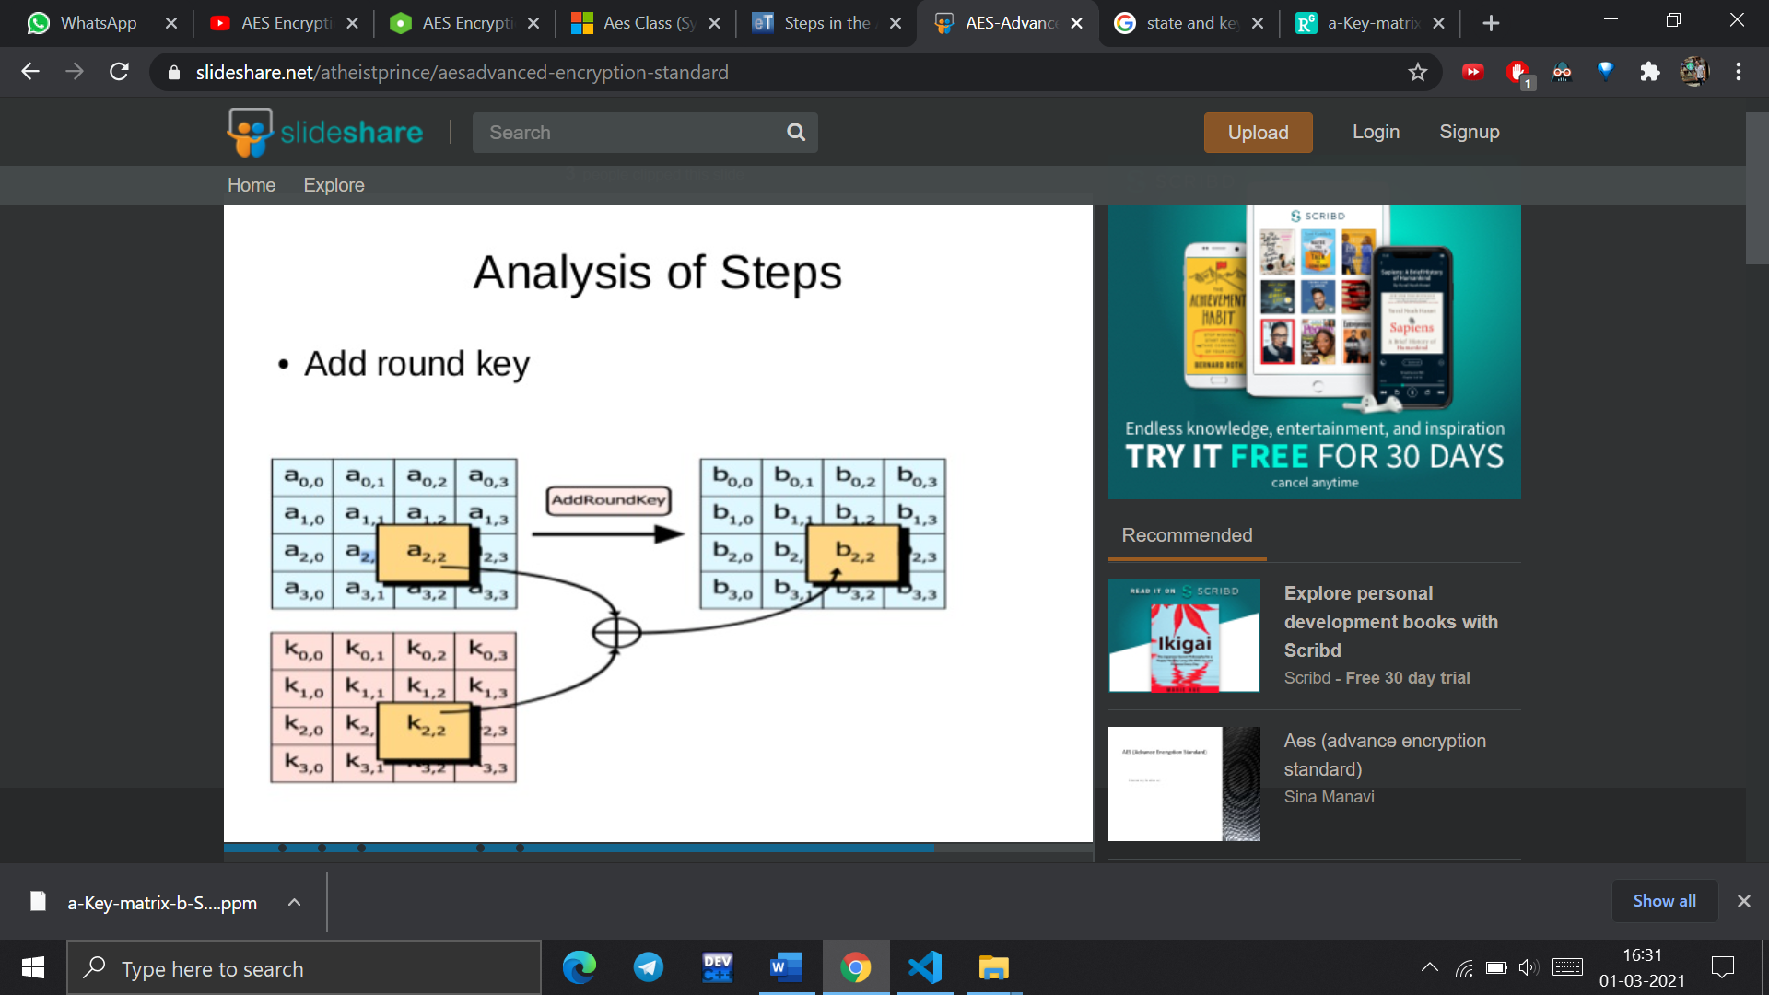

1. **Sub_Bytes**

void Sub_Bytes(unsigned char *state)

    {

        for(int i=0;i<16;i++)

            state[i]=s_box[state[i]];

    }

**Description:**

This operation is a simple substitution that converts every byte into a different value. AES defines a table of 256 values for the substitution. You work through the 16 bytes of the state array, use each byte as an index into the 256-byte substitution table, and replace the byte with the value from the substitution table. Because all possible 256 byte values are present in the table, you end up with a totally new result in the state array, which can be restored to its original contents using an inverse substitution table. The contents of the substitution table are not arbitrary; the entries are computed using a mathematical formula but most implementations will simply have the substitution table stored in memory as part of the design.

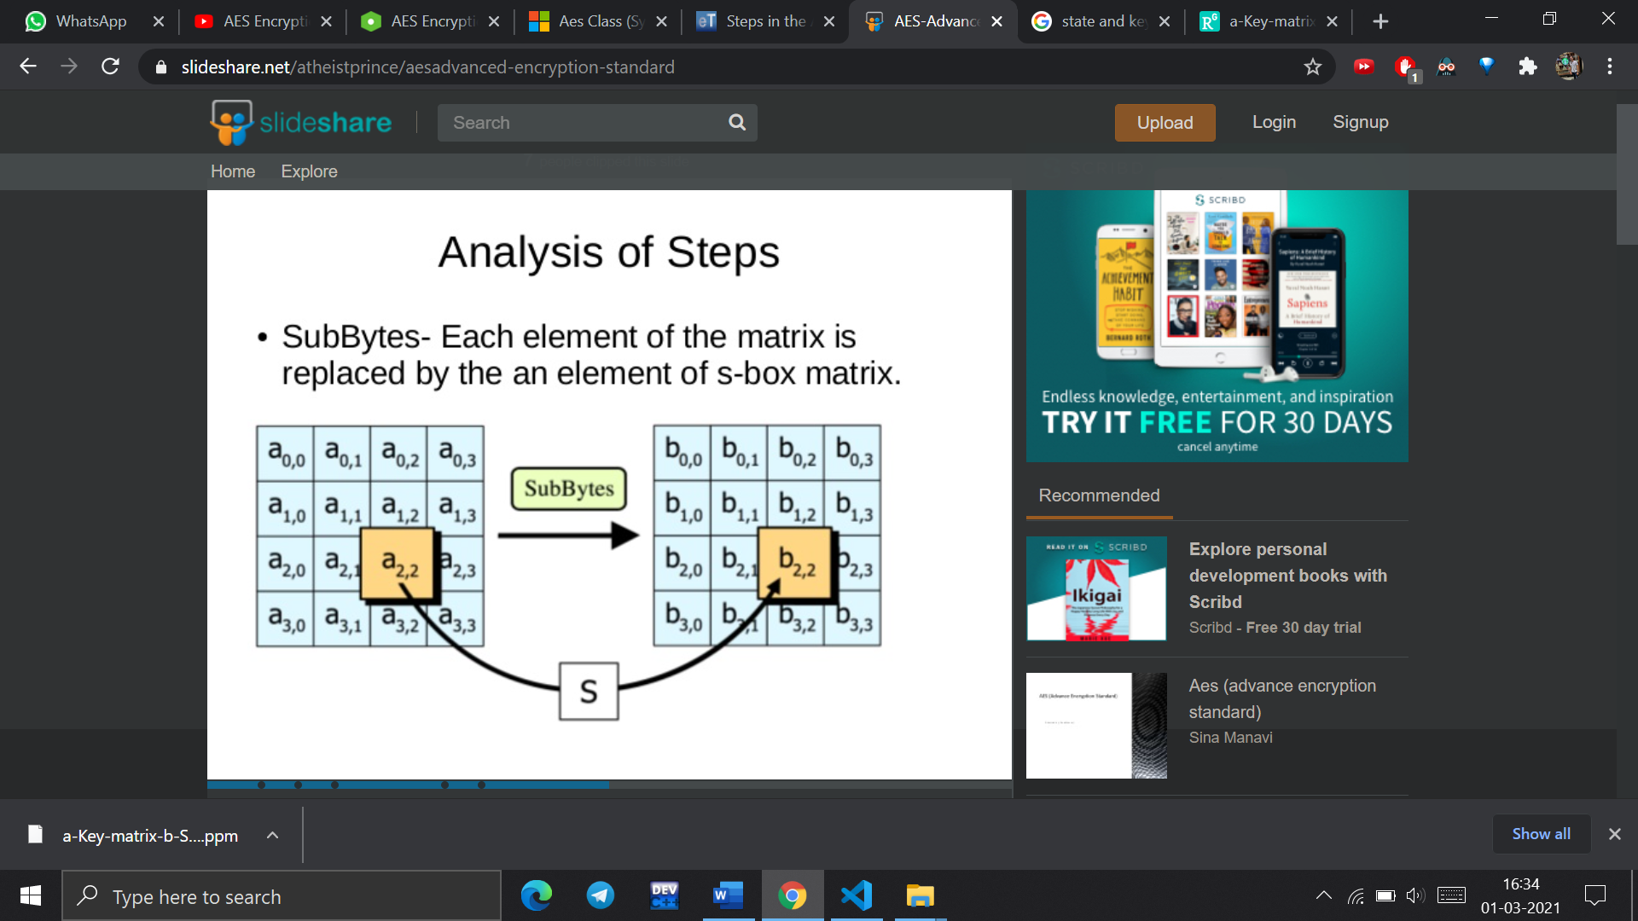

1. **Shift Rows**

void Shift_Rows(unsigned char *state)

    {

        unsigned char tmp[16];

        tmp[0]=state[0];

        tmp[1]=state[5];

        tmp[2]=state[10];

        tmp[3]=state[15];

        tmp[4]=state[4];

        tmp[5]=state[9];

        tmp[6]=state[14];

        tmp[7]=state[3];

        tmp[8]=state[8];

        tmp[9]=state[13];

        tmp[10]=state[2];

        tmp[11]=state[7];

        tmp[12]=state[12];

        tmp[13]=state[1];

        tmp[14]=state[6];

        tmp[15]=state[11];

        for(int i=0;i<16;i++)

            state[i]=tmp[i];

    }

**Description:**

As the name suggests, ShiftRows operates on each row of the state array. Each row is rotated to the left by a certain number of bytes as follows: 1st Row: rotated by 0 bytes (i.e., is not changed) 2nd Row: rotated by 1 byte 3rd Row: rotated by 2 bytes 4th Row: rotated by 3 bytes.

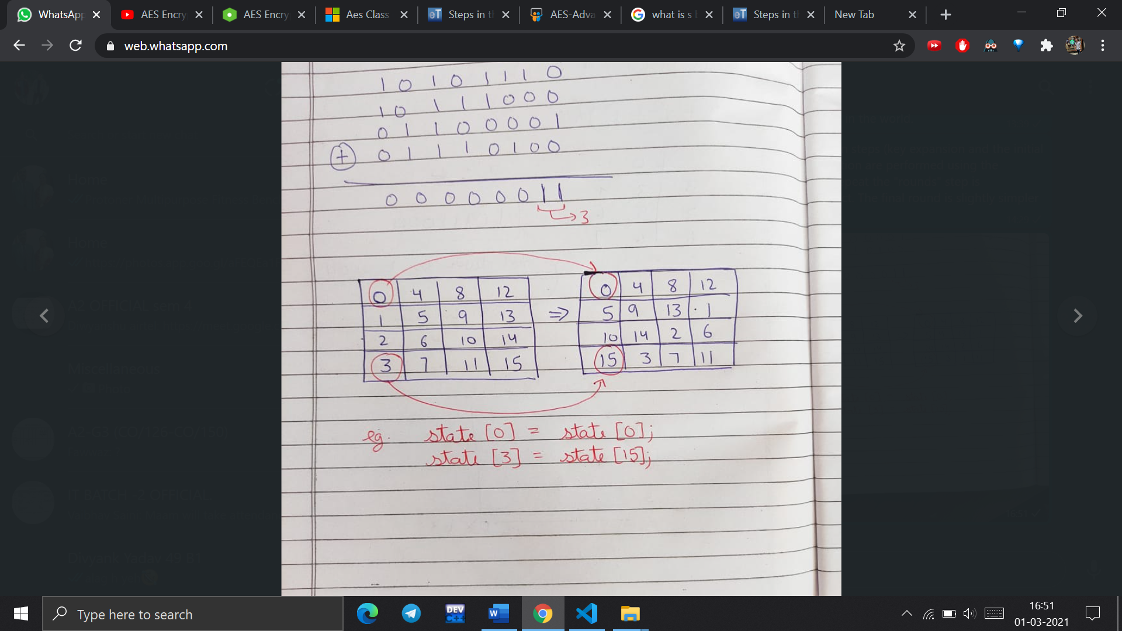

1. **Mix Cloumns**

void Mix_Columns(unsigned char *state)

{

unsigned char tmp[16];

tmp[0] = (unsigned char)(mul2[state[0]] ^ mul3[state[1]] ^ state[2] ^ state[3]);

tmp[1] = (unsigned char)(state[0] ^ mul2[state[1]] ^ mul3[state[2]] ^ state[3]);

tmp[2] = (unsigned char)(state[0] ^ state[1] ^ mul2[state[2]] ^ mul3[state[3]]);

tmp[3] = (unsigned char)(mul3[state[0]] ^ state[1] ^ state[2] ^ mul2[state[3]]);

tmp[4] = (unsigned char)(mul2[state[4]] ^ mul3[state[5]] ^ state[6] ^ state[7]);

tmp[5] = (unsigned char)(state[4] ^ mul2[state[5]] ^ mul3[state[6]] ^ state[7]);

tmp[6] = (unsigned char)(state[4] ^ state[5] ^ mul2[state[6]] ^ mul3[state[7]]);

tmp[7] = (unsigned char)(mul3[state[4]] ^ state[5] ^ state[6] ^ mul2[state[7]]);

tmp[8] = (unsigned char)(mul2[state[8]] ^ mul3[state[9]] ^ state[10] ^ state[11]);

tmp[9] = (unsigned char)(state[8] ^ mul2[state[9]] ^ mul3[state[10]] ^ state[11]);

tmp[10] = (unsigned char)(state[8] ^ state[9] ^ mul2[state[10]] ^ mul3[state[11]]);

tmp[11] = (unsigned char)(mul3[state[8]] ^ state[9] ^ state[10] ^ mul2[state[11]]);

tmp[12] = (unsigned char)(mul2[state[12]] ^ mul3[state[13]] ^ state[14] ^ state[15]);

tmp[13] = (unsigned char)(state[12] ^ mul2[state[13]] ^ mul3[state[14]] ^ state[15]);

tmp[14] = (unsigned char)(state[12] ^ state[13] ^ mul2[state[14]] ^ mul3[state[15]]);

tmp[15] = (unsigned char)(mul3[state[12]] ^ state[13] ^ state[14] ^ mul2[state[15]]);

for(int i=0;i<16;i++)

    state[i]=tmp[i];

}

* We multiply our state with special matrix.
* To multiply, we are computing many dot products.
* For each dot product, we are multiplying bytes as Galois Fields MOD2
* Then we reduce the answers by performing MOD with a special number 100011011

(Details in attached pdf)

1. **Key Expansion**

void KeyExpansionCore (unsigned char *in, unsigned char i)

{

    unsigned int *q = (unsigned int *) in;

    *q = (*q >> 8) | ((*q & 0xff) << 24);

    //S-Box four bytes

    in[0] = s_box[in[0]];

    in[1] = s_box[in[1]];

    in[2] = s_box[in[2]];

    in[3] = s_box[in[3]];

    //Rcon

    in[0] ^= Rcon[i];

}

void Key_Expansion(unsigned char *inputKey, unsigned char *expandedKeys)

{

    // The first 16 byte are the original key:

    for (int i = 0; i < 16; i++)

       expandedKeys[i] = inputKey[i];

    //Variables:

    int bytesGenerated = 16;    // we hve generated 6 byes so far

    int Rcon_iteration = 1; //rcon ioteration beginsss at 1

    unsigned char temp[4];  //Temporeay storafe for core

    while (bytesGenerated < 176)

    {

        //Read 4 bytes from the core

        for (int i = 0; i < 4; i++)

            temp[i] = expandedKeys[i + bytesGenerated - 4];

        //Perform the core onece for each 16 byte key:

        if (bytesGenerated % 16 == 0)

        {

           KeyExpansionCore (temp, Rcon_iteration);

           Rcon_iteration++;

        }

        {

        for (unsigned char a = 0; a < 4; a++)

        {

            expandedKeys[bytesGenerated]=expandedKeys[bytesGenerated - 16] ^ temp[a];

            bytesGenerated++;

        }

        }

    }

}

**Description:**

* We begin with the key supplied to the algorithm and we perform operations to generate new keys, one for each round. In AES 128 there are an additional 10 rounds, so we need 10 new keys. The key expansion takes a 128 bit (16byte) key and expands it such that we have a new key for each round. Each of these keys is 16 bytes wide, and Key including the first round (which uses the supplied key unchanged), we need a total of 176 bytes, 16 bytes for the each of the 10 rounds, and an additional 16 bytes for the original key.
* The first 16 bytes are the original key.
* Variables: We need to keep track of how many bytes we've generated, the Rcon iteration value, and we need a temporary variable for when we call the core.
* Main Loop:
* Read 4 bytes from the core
* Perform key expansion core for each 16 byte key
* XOR temp with [bytesgenerated-16] and store in expanded keys

1. **Key Expansion Core**

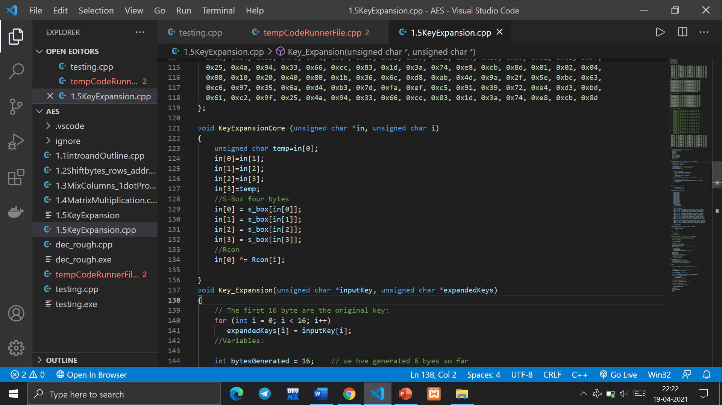

* The core of the algorithm is a set of 3 steps.
* The core takes a block of 4 bytes from the keys generated so far and performs the following operations:
* 1.Rotate: This operation treats the 4 bytes as a single unit. We rotate the bytes left by 1 byte.
* 2. S-Box: In the S-Box step, we swap each byte with the corresponding value from the Rijndael S-Box
* 3. Rcon: For the Rcon step, we raise 2 to the power of i-1, where is the iteration number. We then add this to the value of the first byte.

Implimenting encryption

(cpp file attached )

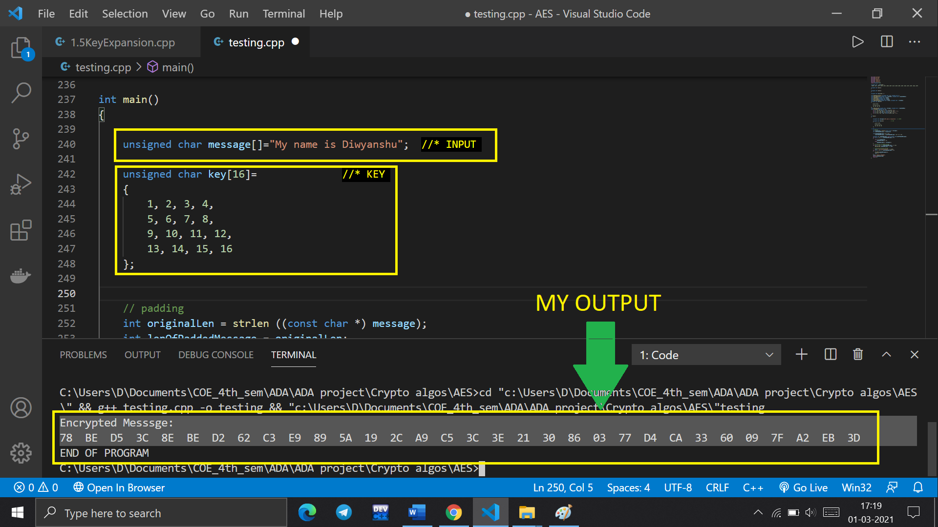

Verifying Output

Using the same input and key on an online AES Tool

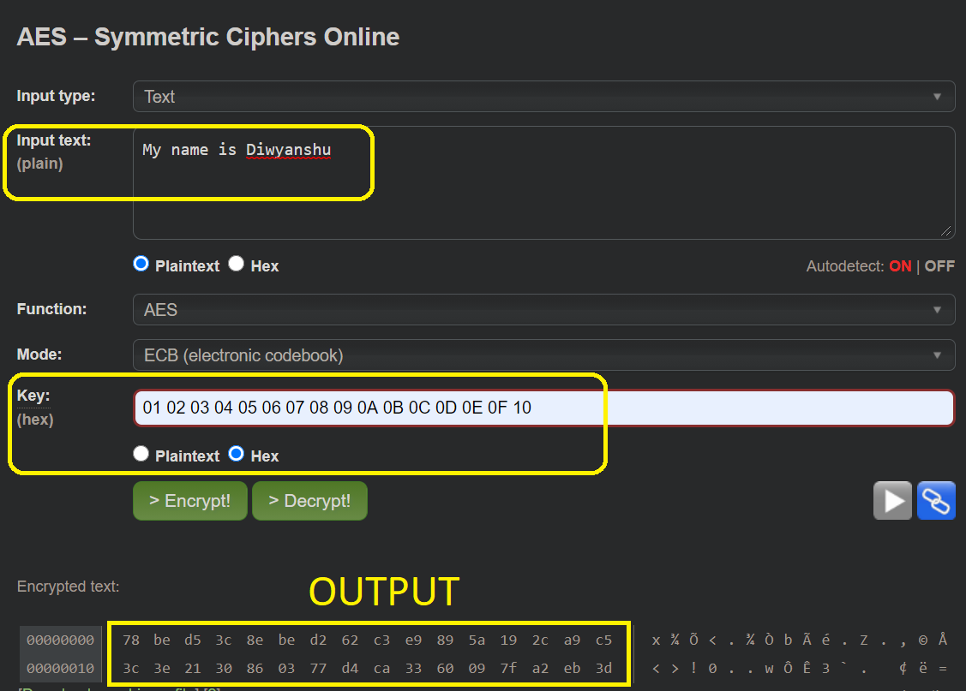Source <http://aes.online-domain-tools.com/>

Output matched with online AES Tool

Decryption

The process of decryption of an AES ciphertext is similar to the encryption process in the reverse order. Each round consists of the four processes conducted in the reverse order −

* Add round key
* Mix columns
* Shift rows
* Byte substitution

Since sub-processes in each round are in reverse manner, the encryption and decryption algorithms need to be separately implemented, although they are very closely related. A set of reverse rounds are applied to transform ciphertext back into the original plaintext using the same encryption key.

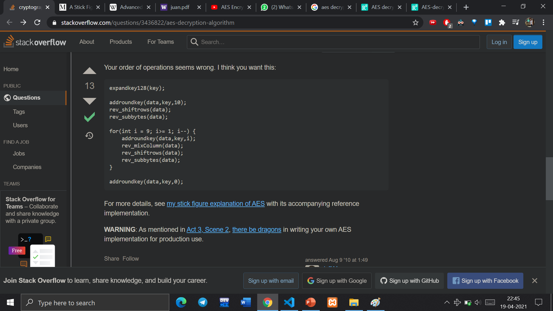

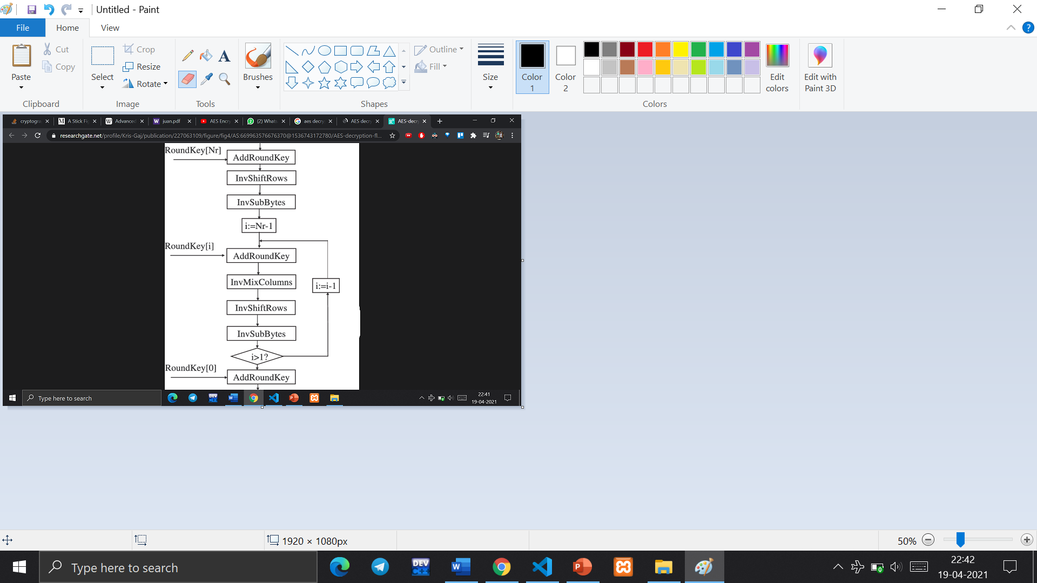

* Add Round Key: Add Round Key is simply an XOR of state with key. So basically, does the same as Add Round Key in the encryption
* Reverse Shift Rows: Shifts rows to right instead of left for decryption.
* Reverse Sub Bytes:  Uses inverse S-box as lookup table
* Reverse Mix Columns: The matrix used to revert the state back to its original standing is given by

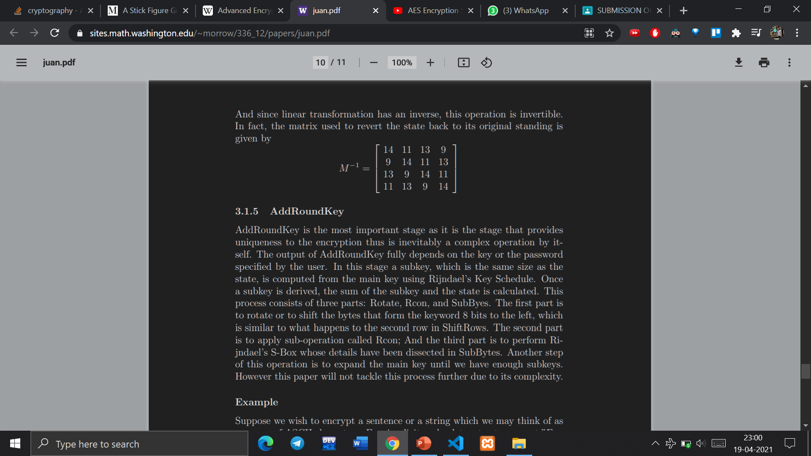

* Reverse Mix Columns uses mul9, mul11, mul13, mul14 look-up tables

AES Analysis

In present day cryptography, AES is widely adopted and supported in both hardware and software. Till date, no practical cryptanalytic attacks against AES has been discovered. Additionally, AES has built-in flexibility of key length, which allows a degree of ‘future-proofing’ against progress in the ability to perform exhaustive key searches.

However, just as for DES, the AES security is assured only if it is correctly implemented and good key management is employed.

Working Screenshots

1. Encryption

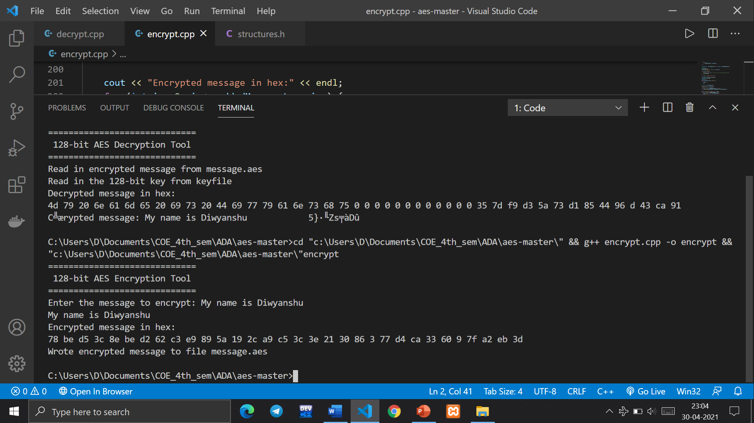

1. Decryption

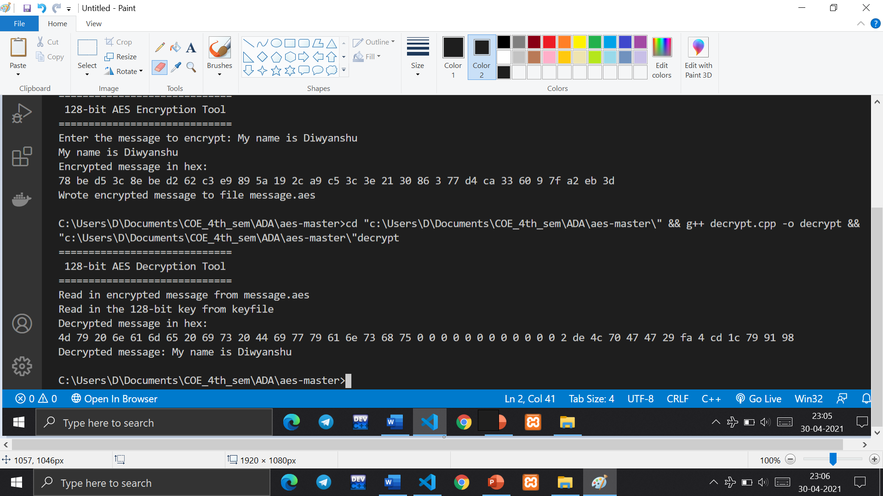

References

* [https://en.wikipedia.org/wiki/Advanced_Encryption_Standard#High-level_description_of_the_algorithm](https://en.wikipedia.org/wiki/Advanced_Encryption_Standard)
* <http://www.moserware.com/2009/09/stick-figure-guide-to-advanced.html>
* <https://sites.math.washington.edu/~morrow/336_12/papers/juan.pdf>
* <https://en.wikipedia.org/wiki/Rijndael_MixColumns>
* <https://www.youtube.com/watch?v=4pmR49izUL0&ab_channel=Creel>
* <https://stackoverflow.com/questions/3436822/aes-decryption-algorithm>
* <http://aes.online-domain-tools.com/>
* <https://en.wikipedia.org/wiki/S-box>
* <https://en.wikipedia.org/wiki/AES_key_schedule>